Presentation Layer

**Home Page**

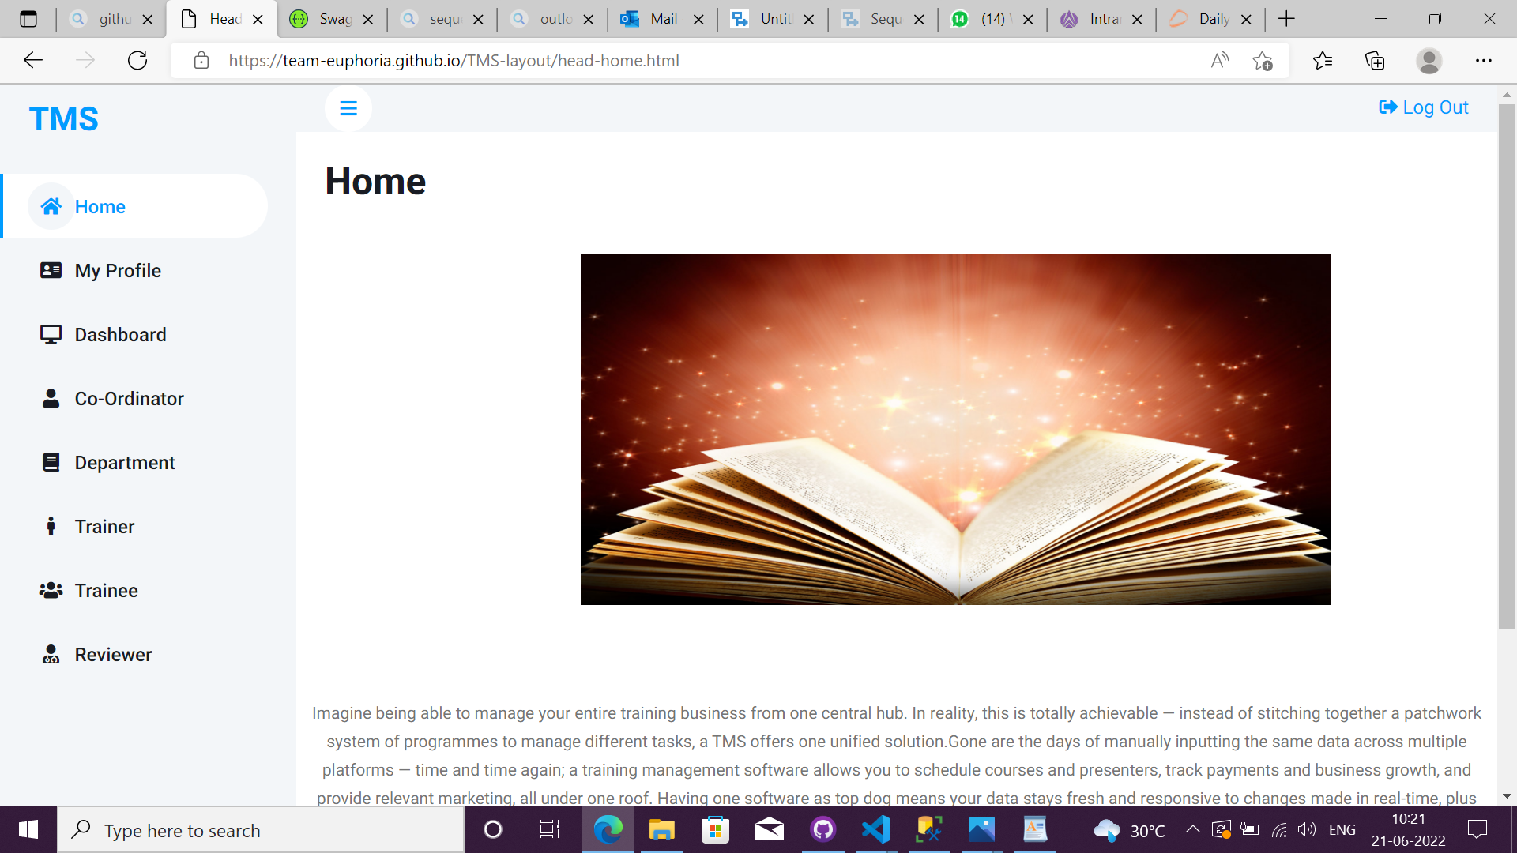

|  |  |
| --- | --- |
| **Description** | Purpose of the screen is to see the display the content about the system. |
| **Security group** |  |
| **Data** | In the screen we display the information about Training management system |
| **Action** | Logout – The user can logout his/her account  Toggle- The user can toggle the navbar  Navbar- The user can move to the respective pages. |

**Dashboard page**

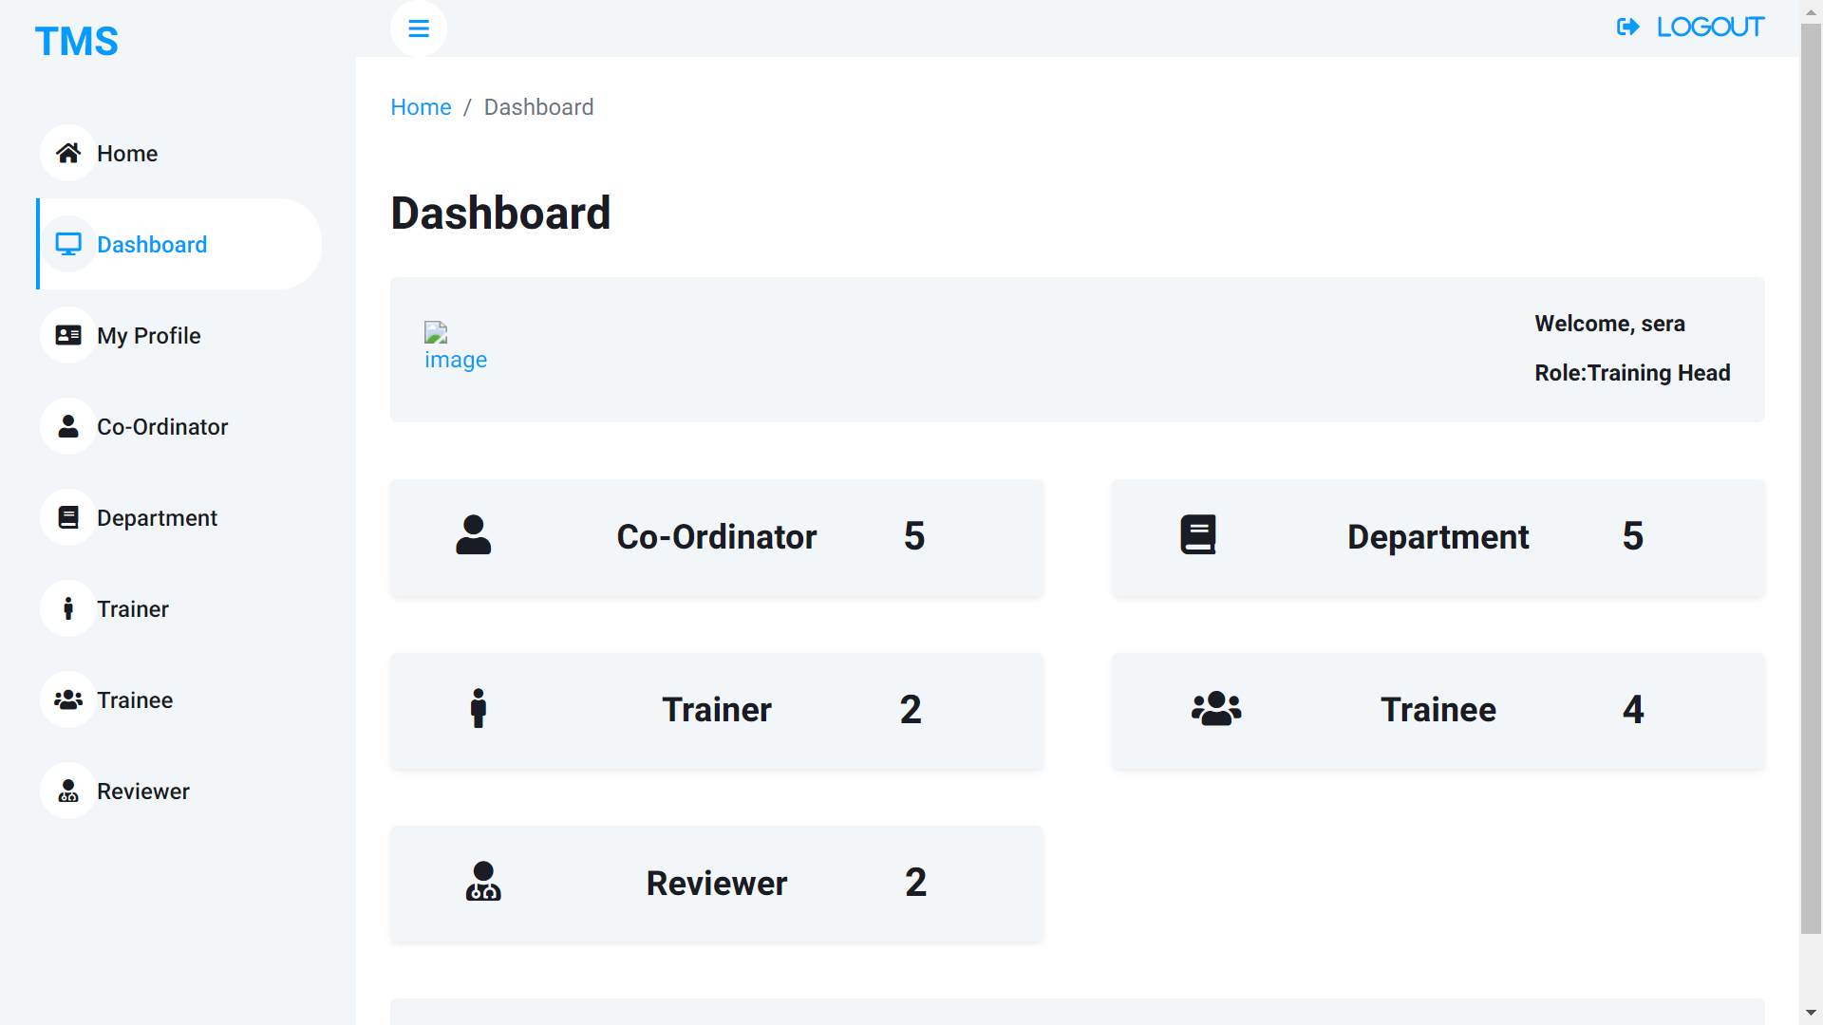

|  |  |
| --- | --- |
| **Description** | The purpose of the screen is to display the dashboard of the Training Head. |
| **Security group** |  |
| **Data** | In this screen we display the count of the Co-ordinator, Department, Trainer, Trainee, Reviewer and Details of Training Head. |
| **Action** | Co-ordinator- The user can see the count and by clicking the user can see the list of the co-ordinator.  Department- The user can see the count and by clicking, the user can see the list of the department.  Trainer- The user can see the count and by clicking, the user can see the list of the trainer.  Trainee- The user can see the count and by clicking, the user can see the list of the trainee.  Reviewer- The user can see the count and by clicking, the user can see the list of the reviewer.  Breadcrumbs- The user can switch between previous page and current page. |

**My profile page**

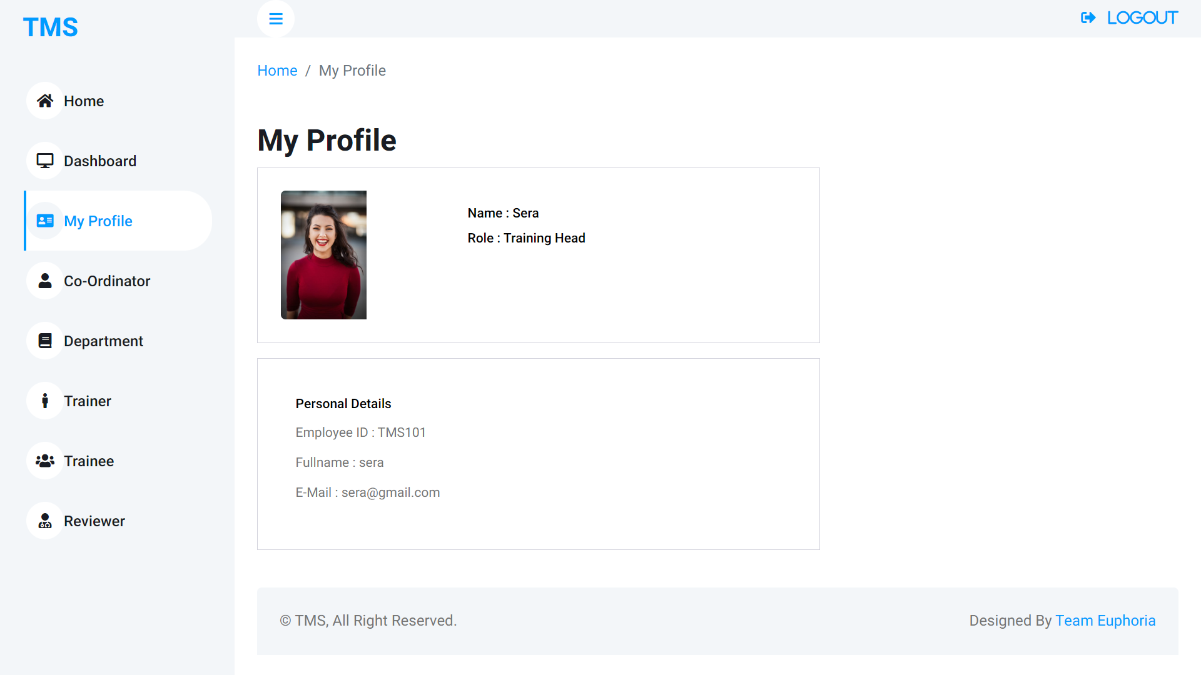

|  |  |
| --- | --- |
| **Description** | Purpose of the screen is to display the user information. |
| **Security group** |  |
| **Data** | In this screen we display the personal information about the training head. |
| **Action** | - |

**Co-ordinator List Page**

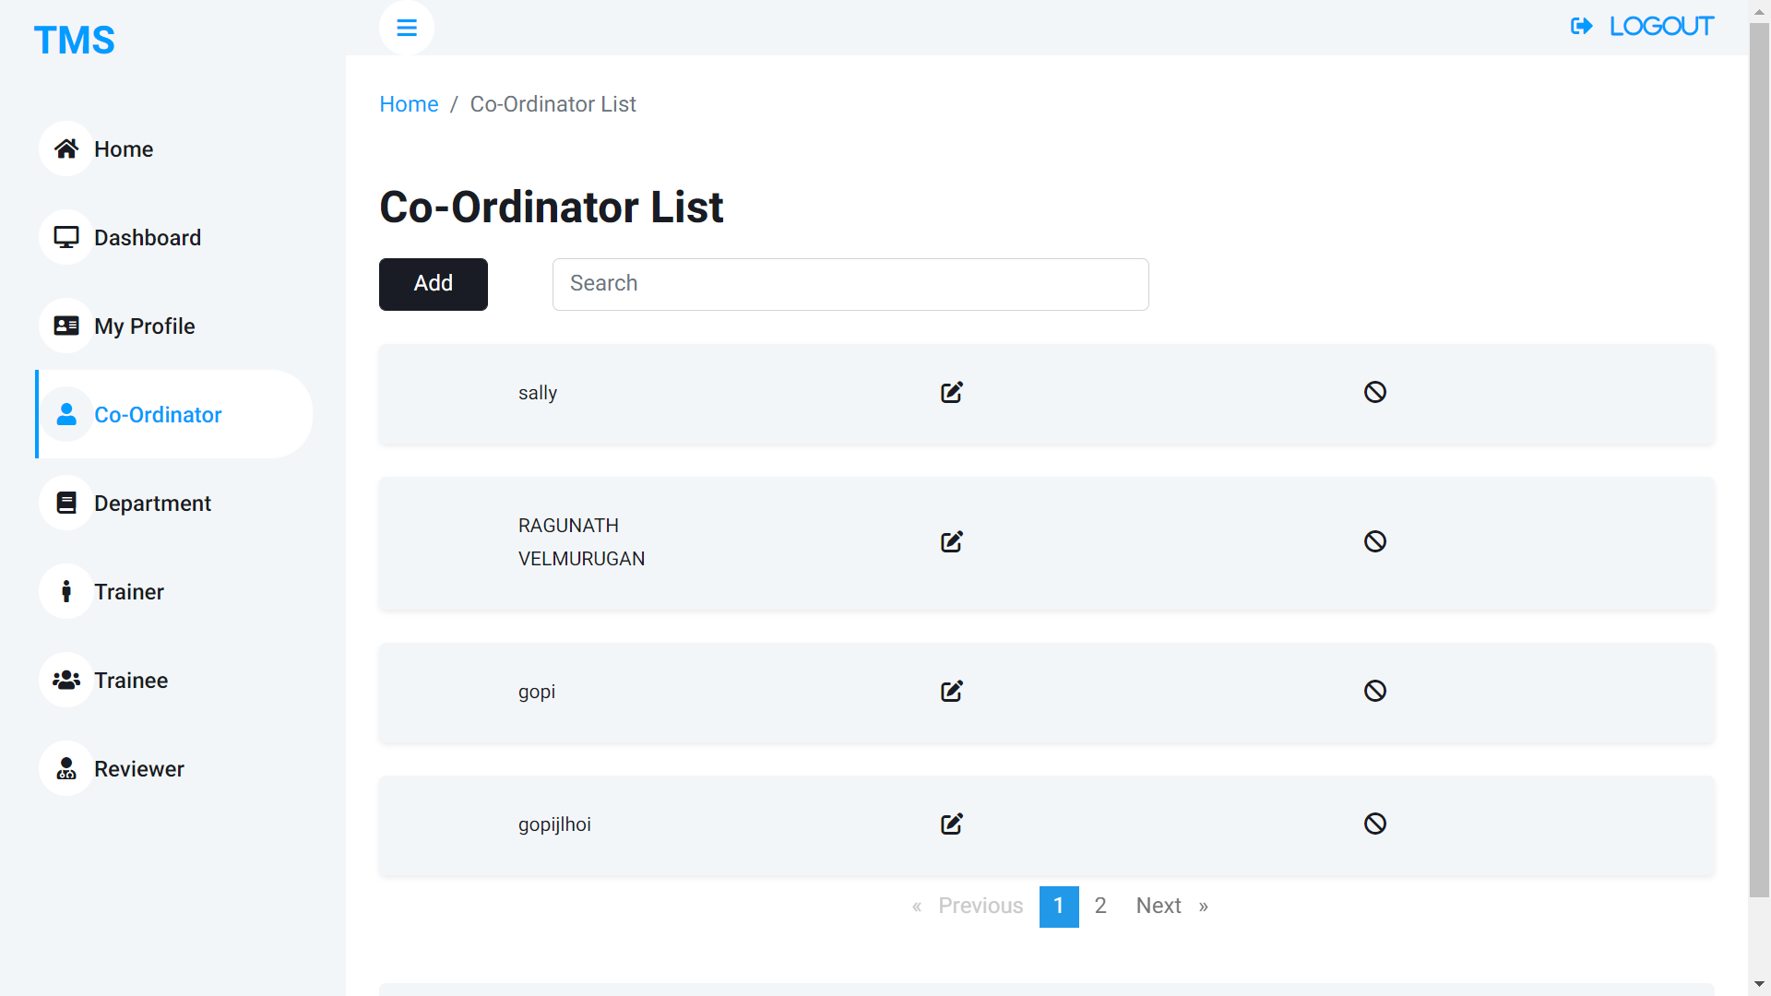

|  |  |
| --- | --- |
| **Description** | Purpose of the screen is to display the list of co-ordinators and to switch to the add co-ordinator screen. |
| **Security group** |  |
| **Data** | In this screen we display the list of co-ordinators in the system |
| **Action** | Search bar- The user can search the co-ordinator by their name.  Add button – This button navigates the user to the add co-ordinator page, where the user can add co-ordinator.  Edit – The option navigates the user to the edit co-ordinator page, where the user can edit the co-ordinator.  Disable- The user can disable the co-ordinator.  Pagination- The user can move to the next list page. |

**Add co-ordinator page**

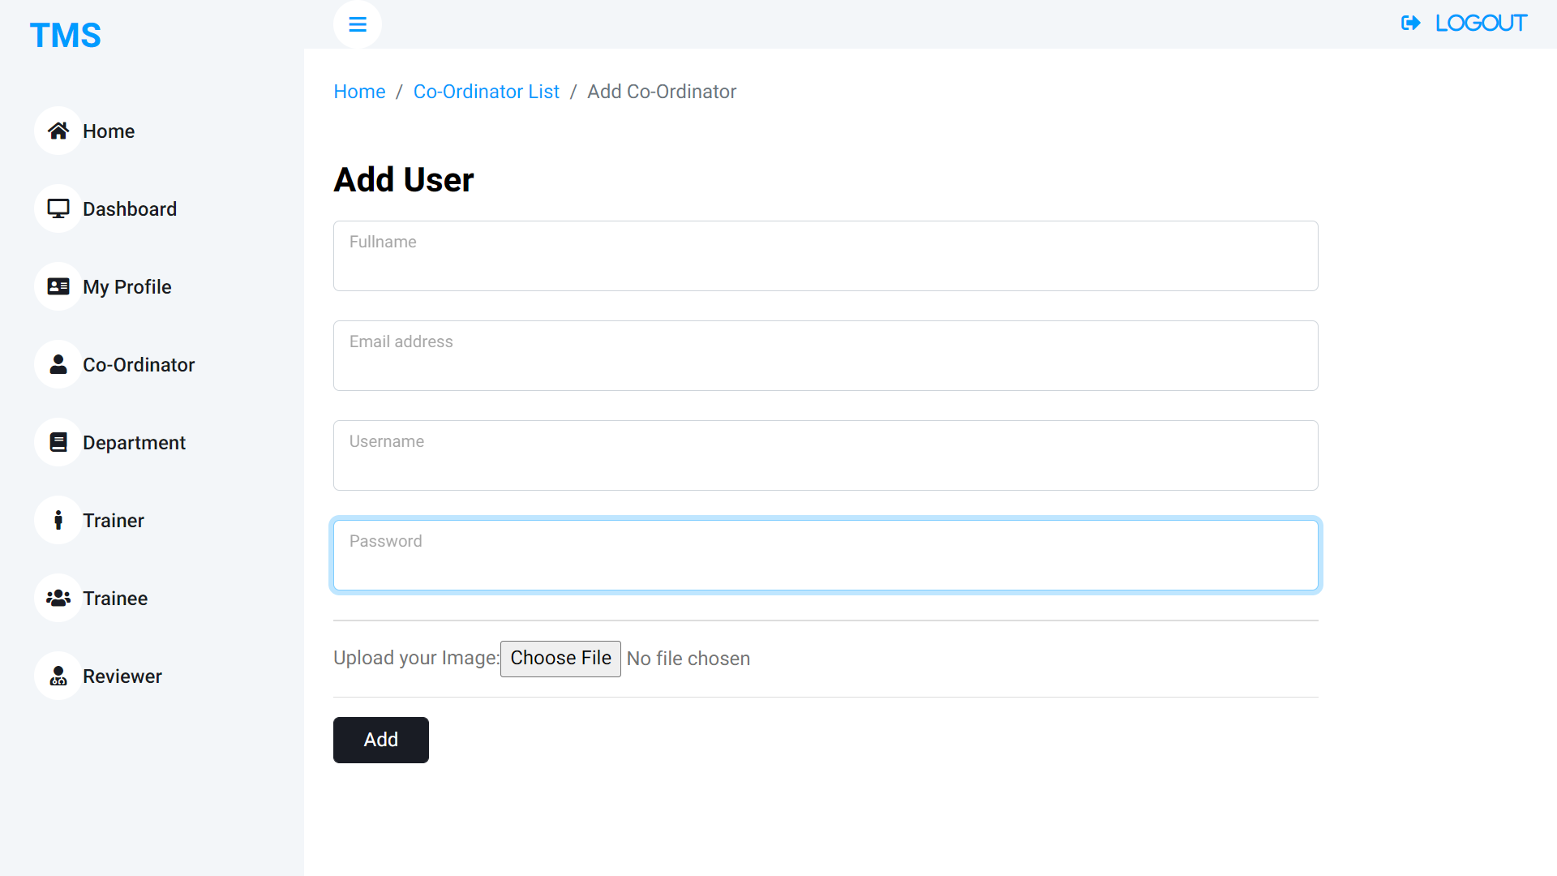

|  |  |
| --- | --- |
| **Description** | Purpose of the screen is to create co-ordinator |
| **Security group** |  |
| **Data** | Here the user enters the Full name, E-mail, Username, Password, Upload image.  All the fields are required in the page.  Some validations are done (Password should contain number and alphabet. It should be minimum 8 character. |
| **Action** | Choose image- The user can upload the image here.  Add- After entering all the details, the user click add button. If all the details are correct the co-ordinator is added to the system. |

**Department list page**

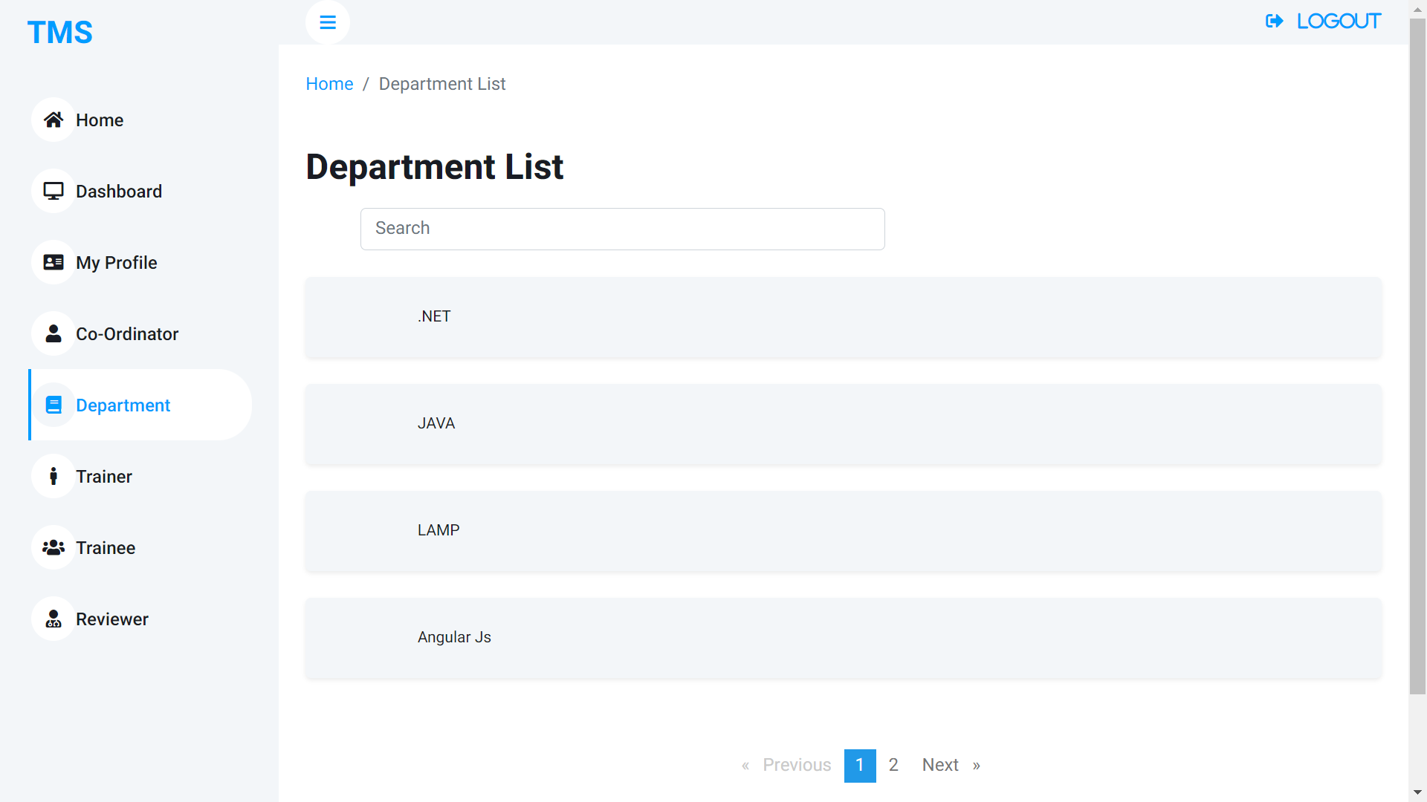

|  |  |
| --- | --- |
| **Description** | Purpose of the screen is to display the list of departments. |
| **Security group** |  |
| **Data** | In this screen we display the list of departments in the system |
| **Action** | Search bar- The user can search the department by their name.  Pagination- The user can move to the next list page. |

**Trainer list page**

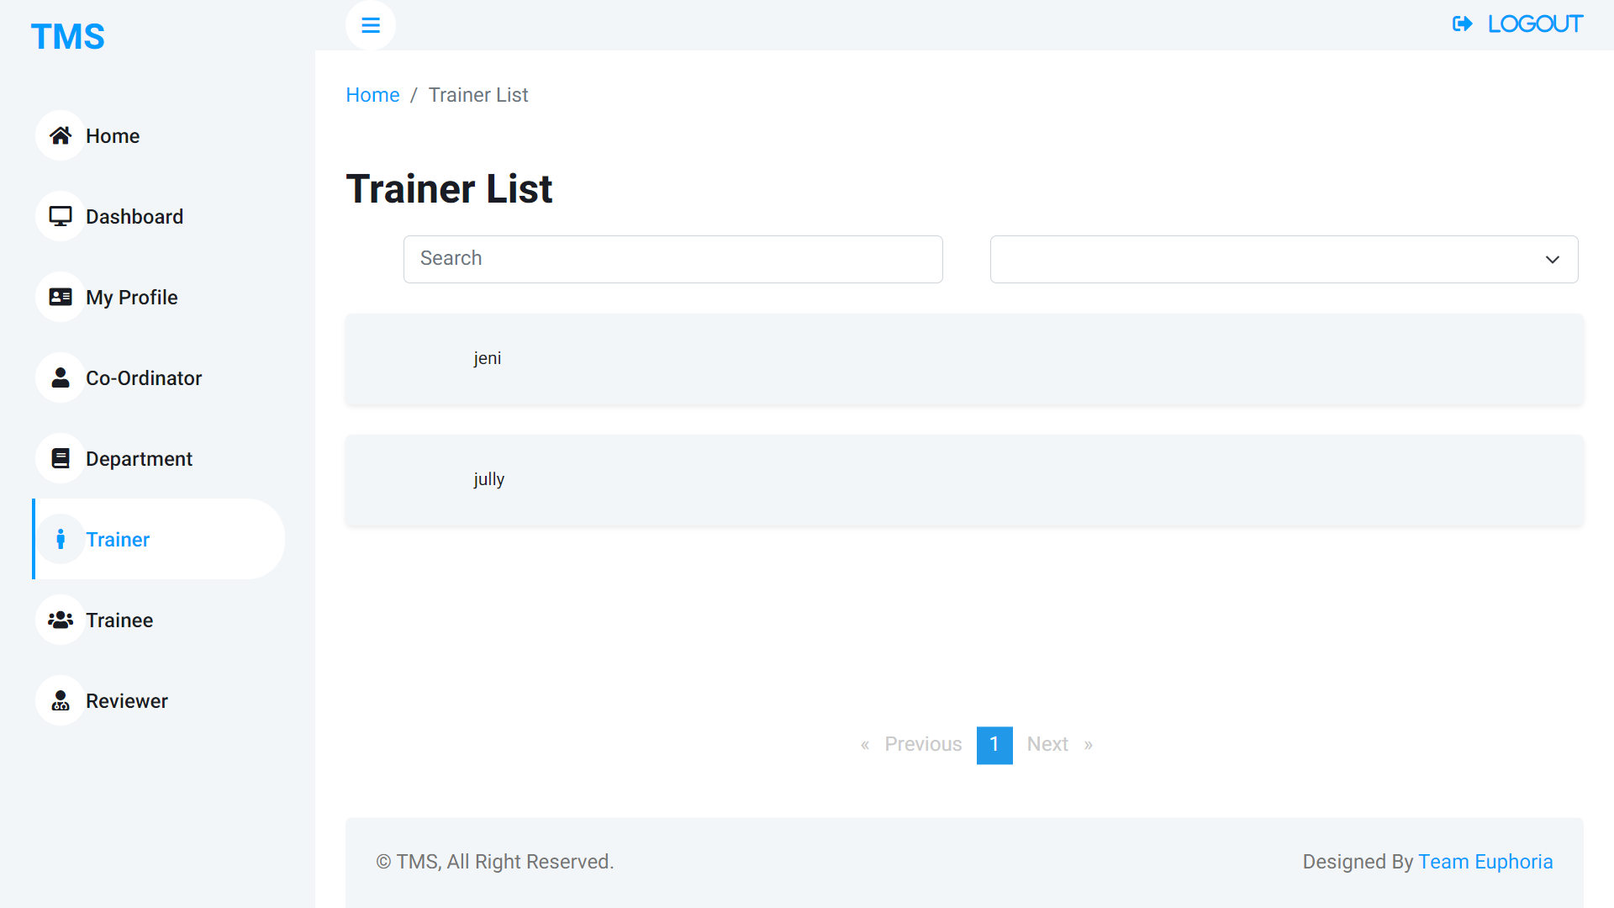

|  |  |
| --- | --- |
| **Description** | Purpose of the screen is to display the list of Trainers. |
| **Security group** |  |
| **Data** | In this screen we display the list of Trainers in the system |
| **Action** | Search bar- The user can search the trainer by their name.  Filter- The user can filter the trainer by their department.  Pagination- The user can move to the next list page. |

**Trainee list page**

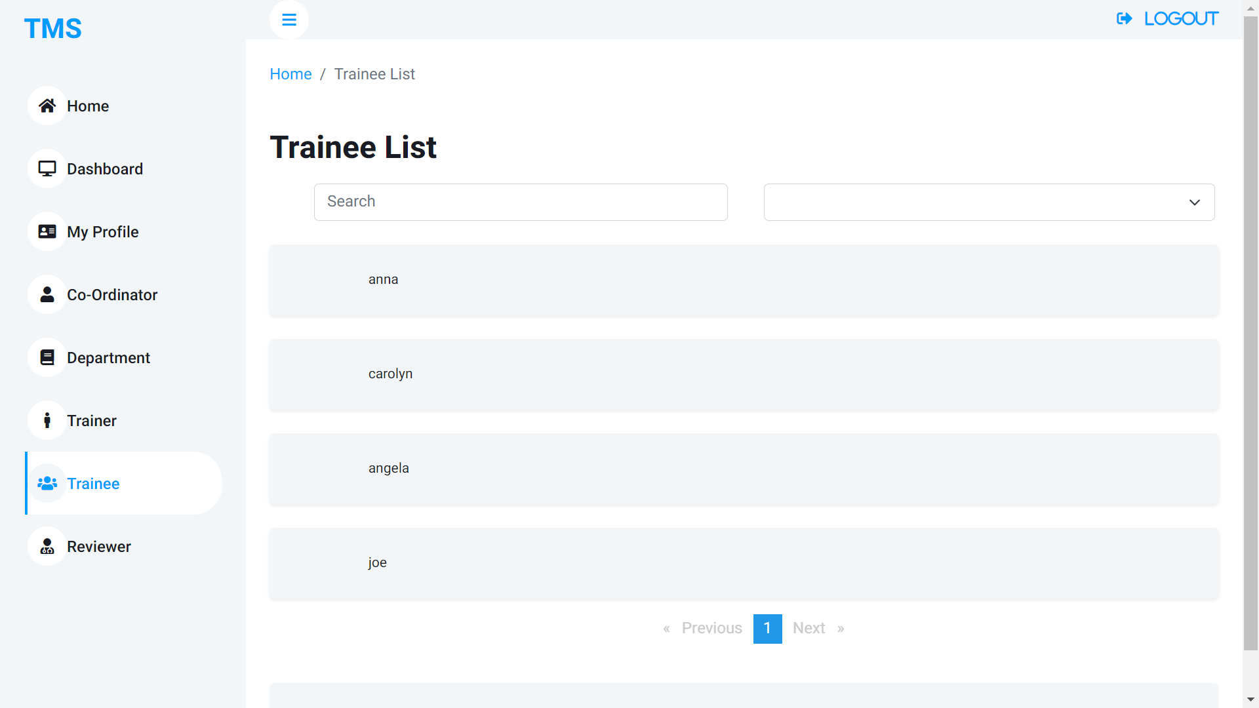

|  |  |
| --- | --- |
| **Description** | Purpose of the screen is to display the list of Trainee. |
| **Security group** |  |
| **Data** | In this screen we display the list of Trainee in the system |
| **Action** | Search bar- The user can search the trainee by their name.  Filter- The user can filter the trainee by their department.  Pagination- The user can move to the next list page. |

**Reviewer list page**

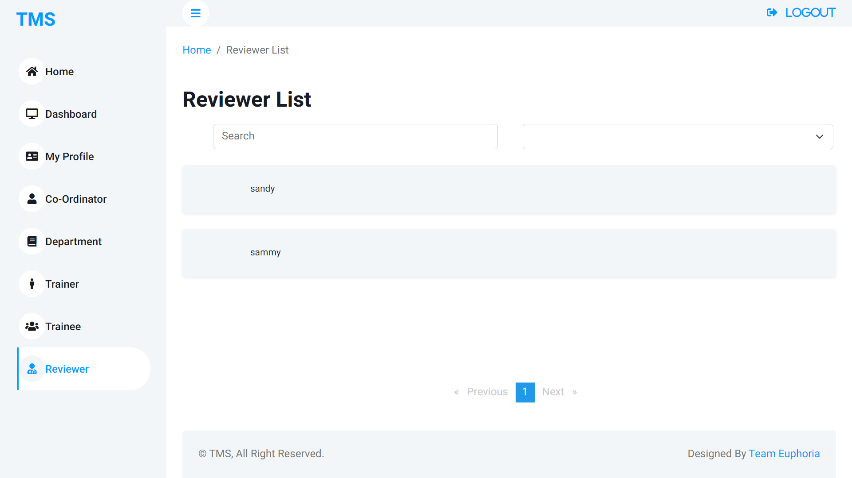

|  |  |
| --- | --- |
| **Description** | Purpose of the screen is to display the list of Reviewer. |
| **Security group** |  |
| **Data** | In this screen we display the list of reviewers in the system |
| **Action** | Search bar- The user can search the reviewer by their name.  Filter- The user can filter the reviewer by their department.  Pagination- The user can move to the next list page. |